Assignment 2 NetProg CWM
Yuzhe Jin
Brasenose College

Ping Test

Test 1:

$ ping 192.168.10.2 -c 10 -i 0.2
PING 192.168.10.2 (192.168.10.2) 56(84) bytes of data.
64 bytes from 192.168.10.2: icmp_seq=1 ttl=64 time=0.528 ms
64 bytes from 192.168.10.2: icmp_seq=2 ttl=64 time=0.425 ms
64 bytes from 192.168.10.2: icmp_seq=3 ttl=64 time=0.476 ms
64 bytes from 192.168.10.2: icmp_seq=4 ttl=64 time=0.480 ms
64 bytes from 192.168.10.2: icmp_seq=5 ttl=64 time=0.402 ms
64 bytes from 192.168.10.2: icmp_seq=6 ttl=64 time=0.479 ms
64 bytes from 192.168.10.2: icmp_seq=7 ttl=64 time=0.507 ms
64 bytes from 192.168.10.2: icmp_seq=8 ttl=64 time=0.501 ms
64 bytes from 192.168.10.2: icmp_seq=9 ttl=64 time=0.484 ms
64 bytes from 192.168.10.2: icmp_seq=10 ttl=64 time=0.371 ms

--- 192.168.10.2 ping statistics ---
10 packets transmitted, 10 received, 0% packet loss, time 1833ms
rtt min/avg/max/mdev = 0.371/0.465/0.528/0.047 ms

Test 2:

ping 192.168.10.1 -c 10 -i 0.2
PING 192.168.10.1 (192.168.10.1) 56(84) bytes of data.
64 bytes from 192.168.10.1: icmp_seq=1 ttl=64 time=0.613 ms
64 bytes from 192.168.10.1: icmp_seq=2 ttl=64 time=0.604 ms
64 bytes from 192.168.10.1: icmp_seq=3 ttl=64 time=0.506 ms
64 bytes from 192.168.10.1: icmp_seq=4 ttl=64 time=0.410 ms
64 bytes from 192.168.10.1: icmp_seq=5 ttl=64 time=0.549 ms
64 bytes from 192.168.10.1: icmp_seq=6 ttl=64 time=0.532 ms
64 bytes from 192.168.10.1: icmp_seq=7 ttl=64 time=0.415 ms
64 bytes from 192.168.10.1: icmp_seq=8 ttl=64 time=0.567 ms
64 bytes from 192.168.10.1: icmp_seq=9 ttl=64 time=0.558 ms
64 bytes from 192.168.10.1: icmp_seq=10 ttl=64 time=0.395 ms

--- 192.168.10.1 ping statistics ---
10 packets transmitted, 10 received, 0% packet loss, time 1849ms
rtt min/avg/max/mdev = 0.395/0.514/0.613/0.076 ms

Test 3:

sudo ping 192.168.10.1 -c 100 -i 0.001
PING 192.168.10.1 (192.168.10.1) 56(84) bytes of data.
64 bytes from 192.168.10.1: icmp_seq=1 ttl=64 time=0.431 ms
64 bytes from 192.168.10.1: icmp_seq=2 ttl=64 time=0.426 ms
64 bytes from 192.168.10.1: icmp_seq=3 ttl=64 time=0.383 ms
64 bytes from 192.168.10.1: icmp_seq=4 ttl=64 time=0.312 ms
64 bytes from 192.168.10.1: icmp_seq=5 ttl=64 time=0.318 ms
64 bytes from 192.168.10.1: icmp_seq=6 ttl=64 time=0.316 ms
64 bytes from 192.168.10.1: icmp_seq=7 ttl=64 time=0.353 ms
64 bytes from 192.168.10.1: icmp_seq=8 ttl=64 time=0.372 ms
64 bytes from 192.168.10.1: icmp_seq=9 ttl=64 time=0.318 ms
64 bytes from 192.168.10.1: icmp_seq=10 ttl=64 time=0.391 ms
64 bytes from 192.168.10.1: icmp_seq=11 ttl=64 time=0.293 ms
64 bytes from 192.168.10.1: icmp_seq=12 ttl=64 time=0.322 ms
64 bytes from 192.168.10.1: icmp_seq=13 ttl=64 time=0.318 ms
64 bytes from 192.168.10.1: icmp_seq=14 ttl=64 time=0.365 ms
64 bytes from 192.168.10.1: icmp_seq=15 ttl=64 time=0.363 ms
64 bytes from 192.168.10.1: icmp_seq=16 ttl=64 time=0.317 ms
64 bytes from 192.168.10.1: icmp_seq=17 ttl=64 time=0.382 ms
64 bytes from 192.168.10.1: icmp_seq=18 ttl=64 time=0.373 ms
64 bytes from 192.168.10.1: icmp_seq=19 ttl=64 time=0.384 ms
64 bytes from 192.168.10.1: icmp_seq=20 ttl=64 time=0.335 ms
64 bytes from 192.168.10.1: icmp_seq=21 ttl=64 time=0.352 ms
64 bytes from 192.168.10.1: icmp_seq=22 ttl=64 time=0.360 ms
64 bytes from 192.168.10.1: icmp_seq=23 ttl=64 time=0.357 ms
64 bytes from 192.168.10.1: icmp_seq=24 ttl=64 time=0.363 ms
64 bytes from 192.168.10.1: icmp_seq=25 ttl=64 time=0.361 ms
64 bytes from 192.168.10.1: icmp_seq=26 ttl=64 time=0.352 ms
64 bytes from 192.168.10.1: icmp_seq=27 ttl=64 time=0.357 ms
64 bytes from 192.168.10.1: icmp_seq=28 ttl=64 time=0.350 ms
64 bytes from 192.168.10.1: icmp_seq=29 ttl=64 time=0.348 ms
64 bytes from 192.168.10.1: icmp_seq=30 ttl=64 time=0.355 ms
64 bytes from 192.168.10.1: icmp_seq=31 ttl=64 time=0.345 ms
64 bytes from 192.168.10.1: icmp_seq=32 ttl=64 time=0.347 ms
64 bytes from 192.168.10.1: icmp_seq=33 ttl=64 time=0.345 ms
64 bytes from 192.168.10.1: icmp_seq=34 ttl=64 time=0.345 ms
64 bytes from 192.168.10.1: icmp_seq=35 ttl=64 time=0.347 ms
64 bytes from 192.168.10.1: icmp_seq=36 ttl=64 time=0.345 ms
64 bytes from 192.168.10.1: icmp_seq=37 ttl=64 time=0.341 ms
64 bytes from 192.168.10.1: icmp_seq=38 ttl=64 time=0.343 ms
64 bytes from 192.168.10.1: icmp_seq=39 ttl=64 time=0.342 ms
64 bytes from 192.168.10.1: icmp_seq=40 ttl=64 time=0.342 ms
64 bytes from 192.168.10.1: icmp_seq=41 ttl=64 time=0.337 ms
64 bytes from 192.168.10.1: icmp_seq=42 ttl=64 time=0.304 ms
64 bytes from 192.168.10.1: icmp_seq=43 ttl=64 time=0.301 ms
64 bytes from 192.168.10.1: icmp_seq=44 ttl=64 time=0.309 ms
64 bytes from 192.168.10.1: icmp_seq=45 ttl=64 time=0.306 ms
64 bytes from 192.168.10.1: icmp_seq=46 ttl=64 time=0.326 ms
64 bytes from 192.168.10.1: icmp_seq=47 ttl=64 time=0.343 ms
64 bytes from 192.168.10.1: icmp_seq=48 ttl=64 time=0.324 ms
64 bytes from 192.168.10.1: icmp_seq=49 ttl=64 time=0.332 ms
64 bytes from 192.168.10.1: icmp_seq=50 ttl=64 time=0.332 ms
64 bytes from 192.168.10.1: icmp_seq=51 ttl=64 time=0.336 ms
64 bytes from 192.168.10.1: icmp_seq=52 ttl=64 time=0.336 ms
64 bytes from 192.168.10.1: icmp_seq=53 ttl=64 time=0.336 ms
64 bytes from 192.168.10.1: icmp_seq=54 ttl=64 time=0.339 ms
64 bytes from 192.168.10.1: icmp_seq=55 ttl=64 time=0.337 ms
64 bytes from 192.168.10.1: icmp_seq=56 ttl=64 time=0.329 ms
64 bytes from 192.168.10.1: icmp_seq=57 ttl=64 time=0.328 ms
64 bytes from 192.168.10.1: icmp_seq=58 ttl=64 time=0.332 ms
64 bytes from 192.168.10.1: icmp_seq=59 ttl=64 time=0.330 ms
64 bytes from 192.168.10.1: icmp_seq=60 ttl=64 time=0.330 ms
64 bytes from 192.168.10.1: icmp_seq=61 ttl=64 time=0.330 ms
64 bytes from 192.168.10.1: icmp_seq=62 ttl=64 time=0.333 ms
64 bytes from 192.168.10.1: icmp_seq=63 ttl=64 time=0.328 ms
64 bytes from 192.168.10.1: icmp_seq=64 ttl=64 time=0.333 ms
64 bytes from 192.168.10.1: icmp_seq=65 ttl=64 time=0.336 ms
64 bytes from 192.168.10.1: icmp_seq=66 ttl=64 time=0.325 ms
64 bytes from 192.168.10.1: icmp_seq=67 ttl=64 time=0.341 ms
64 bytes from 192.168.10.1: icmp_seq=68 ttl=64 time=0.325 ms
64 bytes from 192.168.10.1: icmp_seq=69 ttl=64 time=0.333 ms
64 bytes from 192.168.10.1: icmp_seq=70 ttl=64 time=0.333 ms
64 bytes from 192.168.10.1: icmp_seq=71 ttl=64 time=0.329 ms
64 bytes from 192.168.10.1: icmp_seq=72 ttl=64 time=0.328 ms
64 bytes from 192.168.10.1: icmp_seq=73 ttl=64 time=0.327 ms
64 bytes from 192.168.10.1: icmp_seq=74 ttl=64 time=0.323 ms
64 bytes from 192.168.10.1: icmp_seq=75 ttl=64 time=0.321 ms
64 bytes from 192.168.10.1: icmp_seq=76 ttl=64 time=0.317 ms
64 bytes from 192.168.10.1: icmp_seq=77 ttl=64 time=0.313 ms
64 bytes from 192.168.10.1: icmp_seq=78 ttl=64 time=0.334 ms
64 bytes from 192.168.10.1: icmp_seq=79 ttl=64 time=0.315 ms
64 bytes from 192.168.10.1: icmp_seq=80 ttl=64 time=0.337 ms
64 bytes from 192.168.10.1: icmp_seq=81 ttl=64 time=0.373 ms
64 bytes from 192.168.10.1: icmp_seq=82 ttl=64 time=0.374 ms
64 bytes from 192.168.10.1: icmp_seq=83 ttl=64 time=0.377 ms
64 bytes from 192.168.10.1: icmp_seq=84 ttl=64 time=0.372 ms
64 bytes from 192.168.10.1: icmp_seq=85 ttl=64 time=0.346 ms
64 bytes from 192.168.10.1: icmp_seq=86 ttl=64 time=0.354 ms
64 bytes from 192.168.10.1: icmp_seq=87 ttl=64 time=0.333 ms
64 bytes from 192.168.10.1: icmp_seq=88 ttl=64 time=0.329 ms
64 bytes from 192.168.10.1: icmp_seq=89 ttl=64 time=0.327 ms
64 bytes from 192.168.10.1: icmp_seq=90 ttl=64 time=0.330 ms
64 bytes from 192.168.10.1: icmp_seq=91 ttl=64 time=0.335 ms
64 bytes from 192.168.10.1: icmp_seq=92 ttl=64 time=0.343 ms
64 bytes from 192.168.10.1: icmp_seq=93 ttl=64 time=0.336 ms
64 bytes from 192.168.10.1: icmp_seq=94 ttl=64 time=0.341 ms
64 bytes from 192.168.10.1: icmp_seq=95 ttl=64 time=0.336 ms
64 bytes from 192.168.10.1: icmp_seq=96 ttl=64 time=0.334 ms
64 bytes from 192.168.10.1: icmp_seq=97 ttl=64 time=0.334 ms
64 bytes from 192.168.10.1: icmp_seq=98 ttl=64 time=0.333 ms
64 bytes from 192.168.10.1: icmp_seq=99 ttl=64 time=0.333 ms
64 bytes from 192.168.10.1: icmp_seq=100 ttl=64 time=0.335 ms

--- 192.168.10.1 ping statistics ---
100 packets transmitted, 100 received, 0% packet loss, time 99ms
rtt min/avg/max/mdev = 0.293/0.340/0.431/0.022 ms

Comments;
The minimum, mean and maximum results are 0.293,0.340 and 0.431 milliseconds respectively.
There are relatively minor differences between them.

Test 4:

sudo ping 192.168.10.1 -c 10000 -f
PING 192.168.10.1 (192.168.10.1) 56(84) bytes of data.

--- 192.168.10.1 ping statistics ---
10000 packets transmitted, 10000 received, 0% packet loss, time 3371ms
rtt min/avg/max/mdev = 0.152/0.298/0.518/0.018 ms, ipg/ewma 0.337/0.299 ms

Test 5:

CDF of Ping Test in intervals 0.01 and 1000 measures (Fig 1):

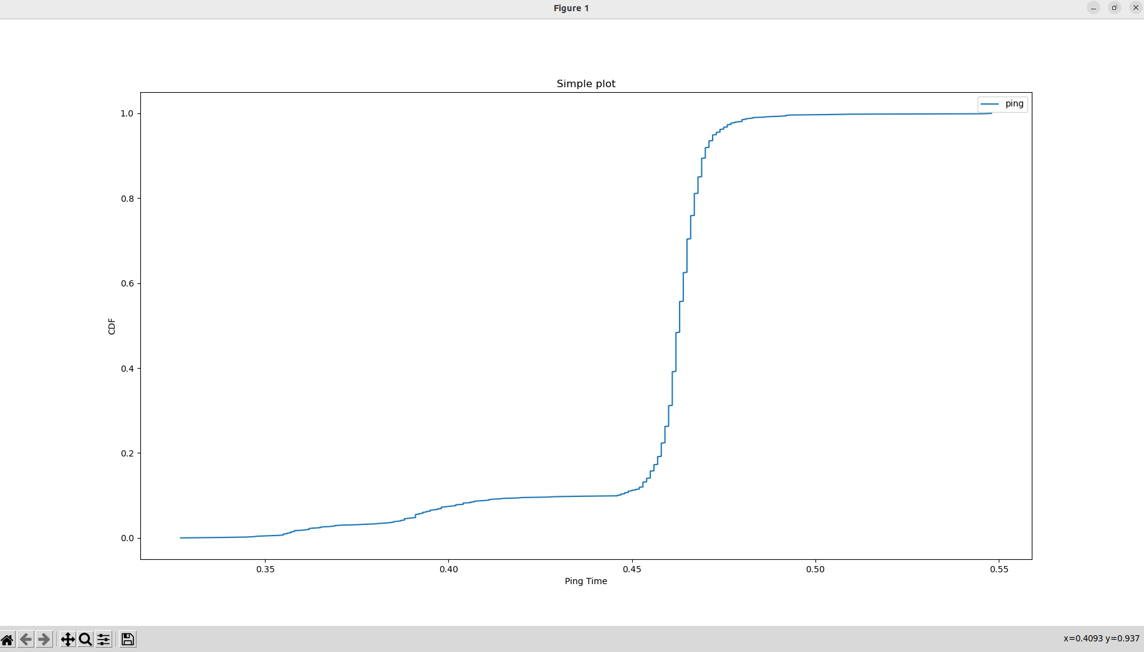
Fig 1

CDF of Ping Test in intervals 0.001 and 1000 measures (Fig 2):
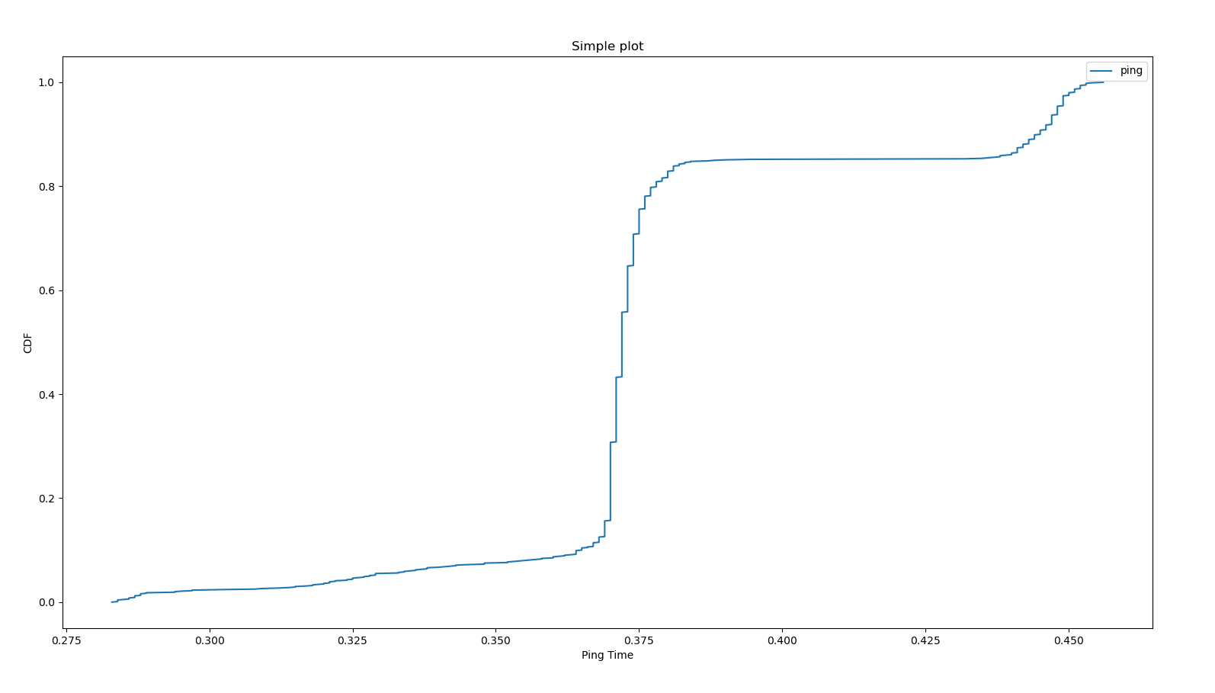
Fig 2

CDF of Ping Test in intervals 0.001 and 1000 measures (Fig 3):
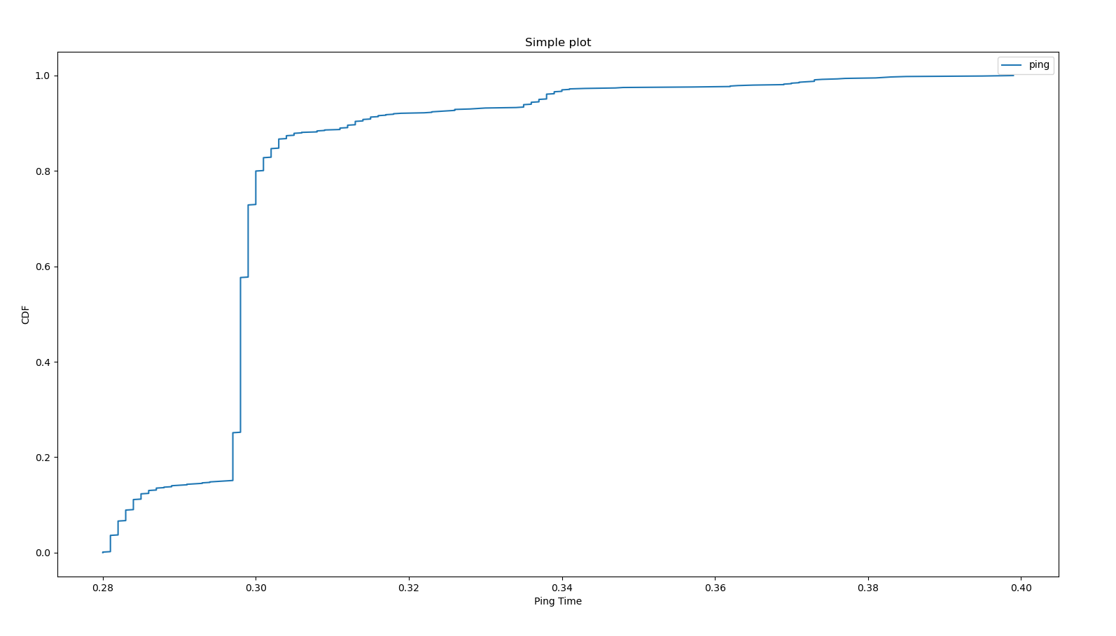
Fig 3

Comments:
Larger intervals of transmission of packets will lead to a greater ping time since latency involved as intervals.
Mean value would be the most accurate measured parameter as the estimation of round trip times because we have removed effects from heavy tails.

Iperf Test

Test 1:

iperf -c 192.168.10.1 -t 10
------------------------------------------------------------
Client connecting to 192.168.10.1, TCP port 5001
TCP window size: 85.0 KByte (default)
------------------------------------------------------------
[ 3] local 192.168.10.2 port 37786 connected with 192.168.10.1 port 5001
[ ID] Interval Transfer Bandwidth
[ 3] 0.0000-10.0063 sec 1.10 GBytes 941 Mbits/sec

iperf -s -B 192.168.10.1
------------------------------------------------------------
Server listening on TCP port 5001
TCP window size: 128 KByte (default)
------------------------------------------------------------
[ 1] local 192.168.10.1 port 5001 connected with 192.168.10.2 port 37786
[ ID] Interval Transfer Bandwidth
[ 1] 0.0000-10.0208 sec 1.10 GBytes 940 Mbits/sec

Test 2:

iperf -c 192.168.10.2 -i 1 -t 10
------------------------------------------------------------
Client connecting to 192.168.10.2, TCP port 5001
TCP window size: 85.0 KByte (default)
------------------------------------------------------------
[ 1] local 192.168.10.1 port 59544 connected with 192.168.10.2 port 5001
[ ID] Interval Transfer Bandwidth
953 Mbits/sec
945 Mbits/sec
940 Mbits/sec
943 Mbits/sec
943 Mbits/sec
945 Mbits/sec
934 Mbits/sec
943 Mbits/sec
948 Mbits/sec
936 Mbits/sec

941 Mbits/sec

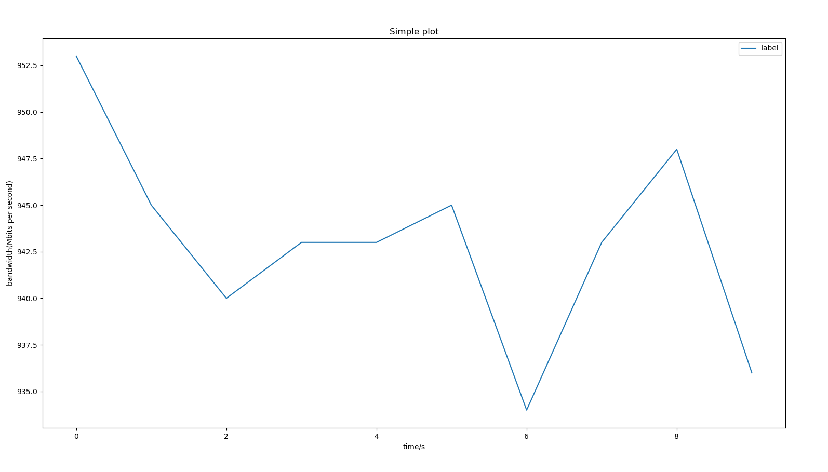
Bandwidth Plot (Fig 4)

Test 3:

Client connecting to 192.168.10.2, TCP port 5001
TCP window size: 85.0 KByte (default)

[ 1] local 192.168.10.1 port 44856 connected with 192.168.10.2 port 5001
[ 2] local 192.168.10.1 port 5001 connected with 192.168.10.2 port 60266
[ ID] Interval Transfer Bandwidth
[ 2] 0.0000-1.0000 sec 109 MBytes 915 Mbits/sec
[ 1] 0.0000-1.0000 sec 111 MBytes 928 Mbits/sec
[ 2] 1.0000-2.0000 sec 110 MBytes 925 Mbits/sec
[ 1] 1.0000-2.0000 sec 111 MBytes 934 Mbits/sec
[ 2] 2.0000-3.0000 sec 110 MBytes 926 Mbits/sec
[ 1] 2.0000-3.0000 sec 112 MBytes 937 Mbits/sec
[ 2] 3.0000-4.0000 sec 110 MBytes 925 Mbits/sec
[ 1] 3.0000-4.0000 sec 111 MBytes 929 Mbits/sec
[ 2] 4.0000-5.0000 sec 109 MBytes 915 Mbits/sec
[ 1] 4.0000-5.0000 sec 112 MBytes 935 Mbits/sec
[ 2] 5.0000-6.0000 sec 110 MBytes 925 Mbits/sec
[ 1] 5.0000-6.0000 sec 112 MBytes 936 Mbits/sec
[ 2] 6.0000-7.0000 sec 110 MBytes 926 Mbits/sec
[ 1] 6.0000-7.0000 sec 111 MBytes 933 Mbits/sec
[ 2] 7.0000-8.0000 sec 110 MBytes 925 Mbits/sec
[ 1] 7.0000-8.0000 sec 111 MBytes 929 Mbits/sec
[ 2] 8.0000-9.0000 sec 110 MBytes 926 Mbits/sec
[ 1] 8.0000-9.0000 sec 111 MBytes 934 Mbits/sec
[ 2] 9.0000-10.0000 sec 110 MBytes 926 Mbits/sec
[ 1] 9.0000-10.0000 sec 112 MBytes 936 Mbits/sec
[ 2] 0.0000-10.0213 sec 1.08 GBytes 923 Mbits/sec
[ 1] 0.0000-10.0284 sec 1.09 GBytes 931 Mbits/sec
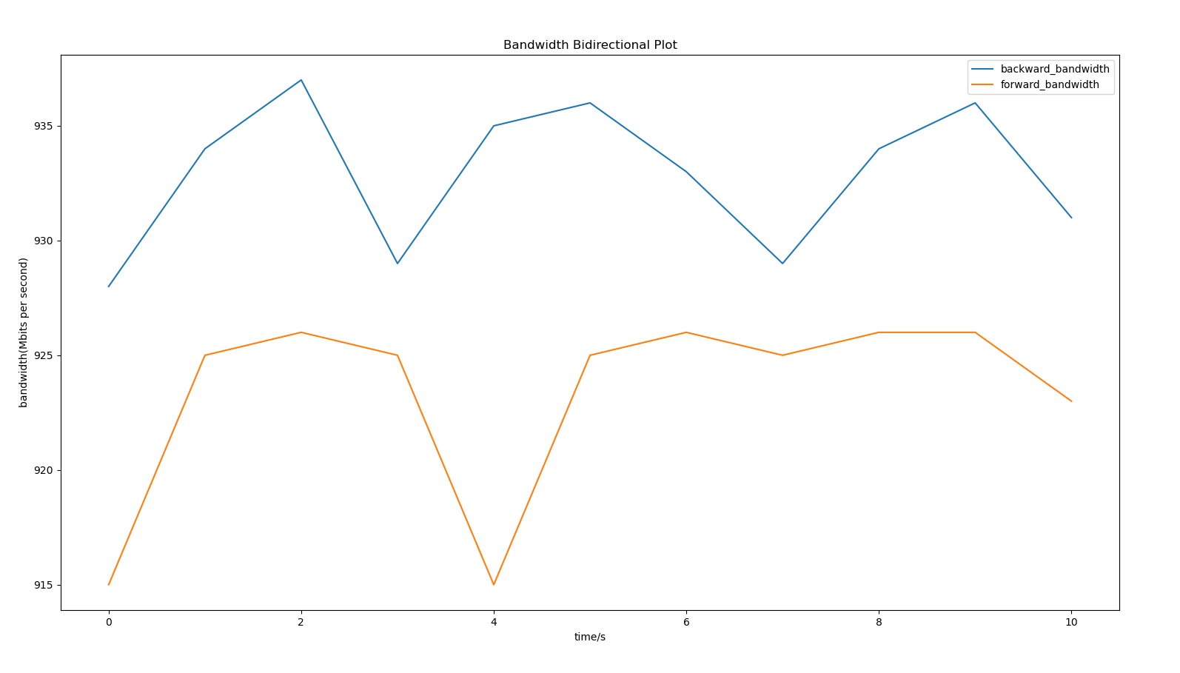
Bidirectional Plot (Fig 5)

Test 4:

sudo iperf -c 192.168.10.1 -t 5 -b 100k -u
------------------------------------------------------------
Client connecting to 192.168.10.1, UDP port 5001
UDP buffer size: 208 KByte (default)
------------------------------------------------------------
[ 3] local 192.168.10.2 port 47623 connected with 192.168.10.1 port 5001
[ ID] Interval Transfer Bandwidth
[ 3] 0.0000-5.1745 sec 64.7 KBytes 102 Kbits/sec
[ 3] Sent 47 datagrams
[ 3] Server Report:
[ ID] Interval Transfer Bandwidth Jitter Lost/Total Datagrams
[ 3] 0.0000-5.1744 sec 64.7 KBytes 102 Kbits/sec 0.066 ms 0/ 46 (0%)

sudo iperf -c 192.168.10.1 -t 5 -b 1m -u
------------------------------------------------------------
Client connecting to 192.168.10.1, UDP port 5001
UDP buffer size: 208 KByte (default)
------------------------------------------------------------
[ 3] local 192.168.10.2 port 58701 connected with 192.168.10.1 port 5001
[ ID] Interval Transfer Bandwidth
[ 3] 0.0000-5.0216 sec 614 KBytes 1.00 Mbits/sec
[ 3] Sent 430 datagrams
[ 3] Server Report:
[ ID] Interval Transfer Bandwidth Jitter Lost/Total Datagrams
[ 3] 0.0000-5.0214 sec 614 KBytes 1.00 Mbits/sec 0.061 ms 0/ 429 (0%)

sudo iperf -c 192.168.10.1 -t 5 -b 100m -u
------------------------------------------------------------
Client connecting to 192.168.10.1, UDP port 5001
UDP buffer size: 208 KByte (default)
------------------------------------------------------------
[ 3] local 192.168.10.2 port 55629 connected with 192.168.10.1 port 5001
[ ID] Interval Transfer Bandwidth
[ 3] 0.0000-5.0002 sec 59.6 MBytes 100 Mbits/sec
[ 3] Sent 42522 datagrams
[ 3] Server Report:
[ ID] Interval Transfer Bandwidth Jitter Lost/Total Datagrams
[ 3] 0.0000-5.0000 sec 59.6 MBytes 100 Mbits/sec 0.020 ms 0/42521 (0%)

Comments:
During all three varying bandwidth tests, no packets have been dropped off.

Iperf3 Test

iperf3 -c 192.168.10.2 -i 1 -t 10
Connecting to host 192.168.10.2, port 5201
[ 5] local 192.168.10.1 port 58224 connected to 192.168.10.2 port 5201
[ ID] Interval Transfer Bitrate Retr Cwnd
[ 5] 0.00-1.00 sec 114 MBytes 959 Mbits/sec 0 475 KBytes
[ 5] 1.00-2.00 sec 112 MBytes 941 Mbits/sec 0 475 KBytes
[ 5] 2.00-3.00 sec 112 MBytes 941 Mbits/sec 0 475 KBytes
[ 5] 3.00-4.00 sec 112 MBytes 941 Mbits/sec 0 475 KBytes
[ 5] 4.00-5.00 sec 112 MBytes 940 Mbits/sec 0 475 KBytes
[ 5] 5.00-6.00 sec 112 MBytes 941 Mbits/sec 0 475 KBytes
[ 5] 6.00-7.00 sec 112 MBytes 940 Mbits/sec 0 475 KBytes
[ 5] 7.00-8.00 sec 112 MBytes 941 Mbits/sec 0 475 KBytes
[ 5] 8.00-9.00 sec 112 MBytes 942 Mbits/sec 0 475 KBytes
[ 5] 9.00-10.00 sec 113 MBytes 948 Mbits/sec 0 475 KBytes
- - - - - - - - - - - - - - - - - - - - - - - - -
[ ID] Interval Transfer Bitrate Retr
[ 5] 0.00-10.00 sec 1.10 GBytes 943 Mbits/sec 0 sender
[ 5] 0.00-10.04 sec 1.10 GBytes 937 Mbits/sec receiver

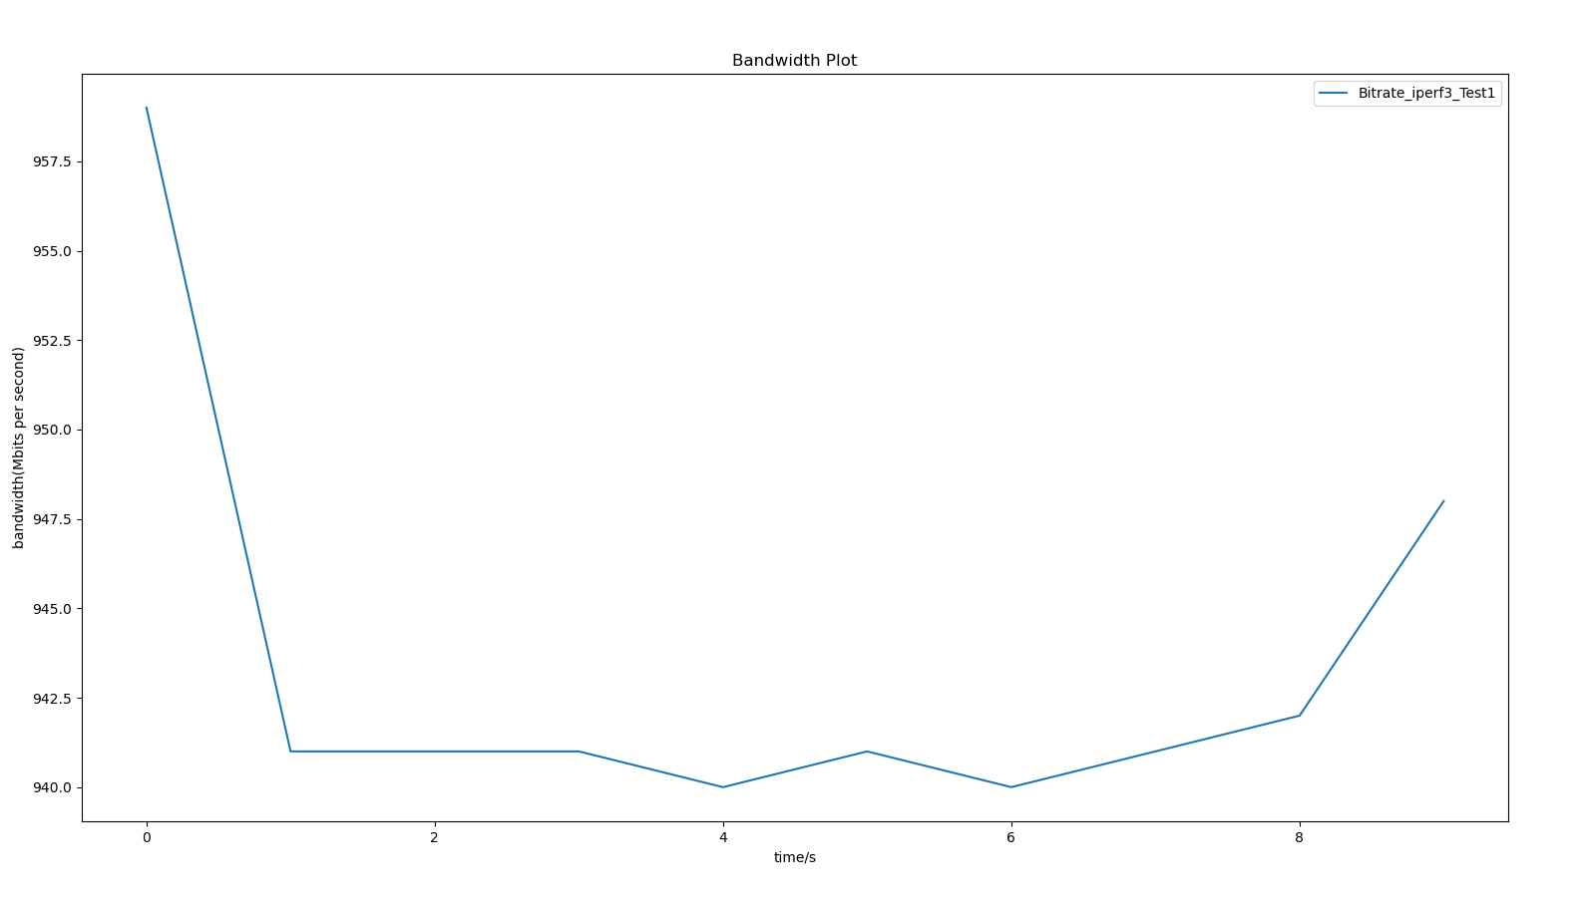
Iperf3 Bandwidth Plot (Fig 6)

Test 2:

iperf3 -c 192.168.10.1 -t 5 -b 100k -u
Connecting to host 192.168.10.1, port 5201
[ 5] local 192.168.10.2 port 41020 connected to 192.168.10.1 port 5201
[ ID] Interval Transfer Bitrate Total Datagrams
[ 5] 0.00-1.00 sec 12.7 KBytes 104 Kbits/sec 9
[ 5] 1.00-2.00 sec 12.7 KBytes 104 Kbits/sec 9
[ 5] 2.00-3.00 sec 11.3 KBytes 92.7 Kbits/sec 8
[ 5] 3.00-4.00 sec 12.7 KBytes 104 Kbits/sec 9
[ 5] 4.00-5.00 sec 12.7 KBytes 104 Kbits/sec 9
- - - - - - - - - - - - - - - - - - - - - - - - -
[ ID] Interval Transfer Bitrate Jitter Lost/Total Datagrams
[ 5] 0.00-5.00 sec 62.2 KBytes 102 Kbits/sec 0.000 ms 0/44 (0%) sender
[ 5] 0.00-5.04 sec 62.2 KBytes 101 Kbits/sec 0.037 ms 0/44 (0%) receiver

iperf3 -c 192.168.10.1 -t 5 -b 1m -u
Connecting to host 192.168.10.1, port 5201
[ 5] local 192.168.10.2 port 41546 connected to 192.168.10.1 port 5201
[ ID] Interval Transfer Bitrate Total Datagrams
[ 5] 0.00-1.00 sec 123 KBytes 1.01 Mbits/sec 87
[ 5] 1.00-2.00 sec 122 KBytes 996 Kbits/sec 86
[ 5] 2.00-3.00 sec 122 KBytes 996 Kbits/sec 86
[ 5] 3.00-4.00 sec 123 KBytes 1.01 Mbits/sec 87
[ 5] 4.00-5.00 sec 122 KBytes 996 Kbits/sec 86
- - - - - - - - - - - - - - - - - - - - - - - - -
[ ID] Interval Transfer Bitrate Jitter Lost/Total Datagrams
[ 5] 0.00-5.00 sec 611 KBytes 1.00 Mbits/sec 0.000 ms 0/432 (0%) sender
[ 5] 0.00-5.04 sec 611 KBytes 993 Kbits/sec 0.072 ms 0/432 (0%) receiver
iperf3 -c 192.168.10.1 -t 5 -b 100m -u
Connecting to host 192.168.10.1, port 5201
[ 5] local 192.168.10.2 port 56308 connected to 192.168.10.1 port 5201
[ ID] Interval Transfer Bitrate Total Datagrams
[ 5] 0.00-1.00 sec 11.9 MBytes 99.9 Mbits/sec 8626
[ 5] 1.00-2.00 sec 11.9 MBytes 100 Mbits/sec 8633
[ 5] 2.00-3.00 sec 11.9 MBytes 100 Mbits/sec 8632
[ 5] 3.00-4.00 sec 11.9 MBytes 100 Mbits/sec 8633
[ 5] 4.00-5.00 sec 11.9 MBytes 100 Mbits/sec 8632
- - - - - - - - - - - - - - - - - - - - - - - - -
[ ID] Interval Transfer Bitrate Jitter Lost/Total Datagrams
[ 5] 0.00-5.00 sec 59.6 MBytes 100 Mbits/sec 0.000 ms 0/43156 (0%) sender
[ 5] 0.00-5.04 sec 59.6 MBytes 99.2 Mbits/sec 0.016 ms 0/43156 (0%) receiver

iperf Done.

Iperf Test Summary:
[ 3] 0.0000-5.1744 sec 64.7 KBytes 102 Kbits/sec 0.066 ms 0/ 46 (0%)
[ 3] 0.0000-5.0214 sec 614 KBytes 1.00 Mbits/sec 0.061 ms 0/ 429 (0%)
[ 3] 0.0000-5.0000 sec 59.6 MBytes 100 Mbits/sec 0.020 ms 0/42521 (0%)

Iperf3 Test Summary:
[ 5] 0.00-5.00 sec 62.2 KBytes 102 Kbits/sec 0.000 ms 0/44 (0%) sender
[ 5] 0.00-5.04 sec 62.2 KBytes 101 Kbits/sec 0.037 ms 0/44 (0%) receiver

[ 5] 0.00-5.00 sec 611 KBytes 1.00 Mbits/sec 0.000 ms 0/432 (0%) sender
[ 5] 0.00-5.04 sec 611 KBytes 993 Kbits/sec 0.072 ms 0/432 (0%) receiver

[ 5] 0.00-5.00 sec 59.6 MBytes 100 Mbits/sec 0.000 ms 0/43156 (0%) sender
[ 5] 0.00-5.04 sec 59.6 MBytes 99.2 Mbits/sec 0.016 ms 0/43156 (0%) receiver

Comments: During all three varying bandwidth tests, no packets have been dropped off.

Overall, we could see that both iperf and iperf3 tests have quite close testing results in terms of packet dropping rate(0%) and jitter as delay of packet arrival time. The datagrams and bytes transmitted are quite close as well.

The only difference seems to be at jitter time in jitter times for the 100k and 1M bandwidth testing: iperf got around 0.06 ms latency while iperf3 obtained 0.04 and 0.07 ms latency respectively.

